Streamline your planning experience with ePlanning– our planning portal designed to make submitting and managing applications easier and faster.
ePlanning allows you to:
- Submit and manage planning permit applications
- Make secure online payments
- Track an application’s progress
- Access the planning register and view details of applications
- Make submissions to an application on public notice
- Request written advice and copies of documents
- Upload further information or additional documents
- Submit plans to comply with permit conditions
You can access ePlanning at eplanning.cardinia.vic.gov.au.
This guide outlines step-by-step instructions for using ePlanning, including account setup, lodgement, document uploads, fee payments, submissions, and other processes.

Contents

How do I register for ePlanning? 2
Drafts 3
Activities 3
How do I lodge an application for a permit? 4
How do I lodge an application to amend a permit? 5
How do I submit information for an existing application? 6
How do I pay fees (or view outstanding fees) for my application? 7
How do I submit plans to comply with a permit condition? 9
How do I make a submission (objection or support) for an application? 10
How to lodge an Enquiry? 11
How do I access the Planning Register? 12
How do I amend my current application for a planning permit? 14
Applications that cannot be lodged via ePlanning 15
How to lodge a secondary consent application 15
How to lodge an extension of time (for a planning permit that has already been issued) 15
How do I request a pre-application meeting? 16
How to apply for consent to build outside of building envelope 16
What if I need assistance? 16

How do I register for ePlanning?
You need to be a registered user to access many of ePlanning’s functions.
- To register, select ‘Register here’ from the ePlanning home page at https://eplanning.cardinia.vic.gov.au/ and complete all required fields.
- Once registered, you can login using your email address and password.
- After logging in, your dashboard will display any Drafts and Activities associated with your account.
- From the dashboard, you can:
  - Submit a new application
  - Respond to information requests
  - Make an enquiry
  - Lodge a submission
  - Search the planning register

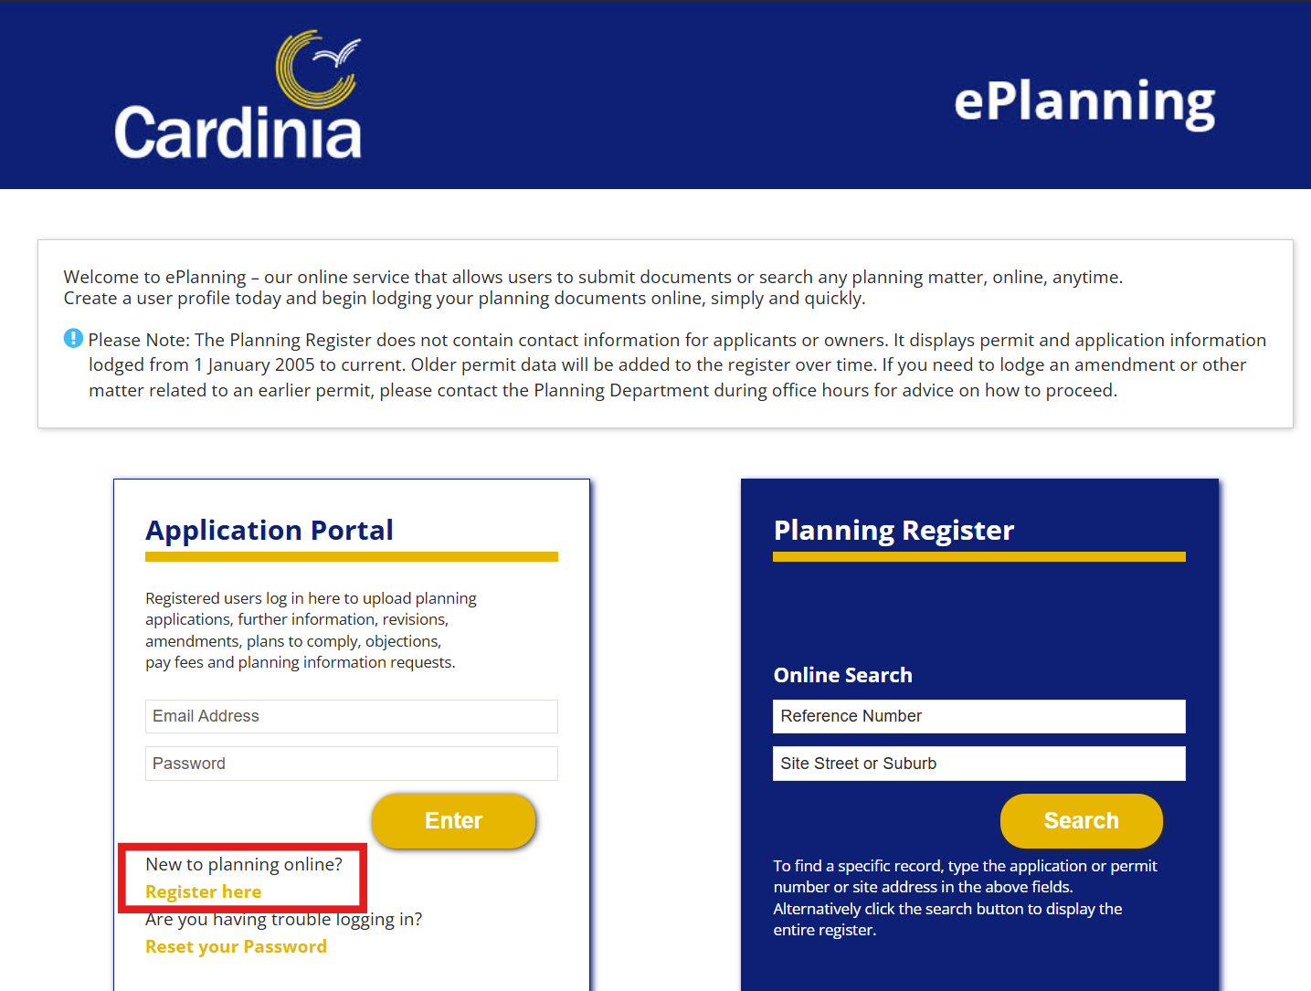

Drafts
Drafts will display all incomplete activities associated with your account. To continue with an activity, select ‘Complete’. To delete an activity, select ‘Delete’.

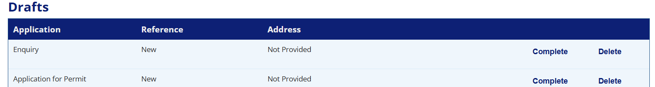

Activities
Activities will display all submitted applications, requests, enquiries and submissions completed by your account. Depending on the status and progress of each activity, you may be able to perform certain actions.

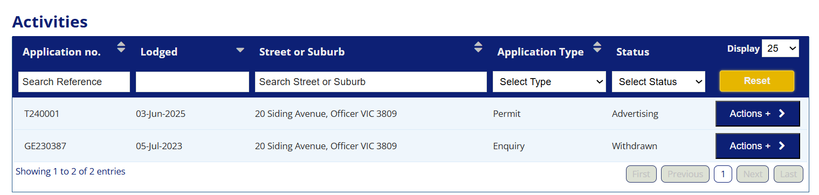

How do I lodge an application for a permit?
You must be logged in with your registered account to begin the application process.
- To lodge an application for a planning permit, select the ‘Submit an Application’ tab from the ePlanning home page and follow the prompts.
To lodge an application to amend a permit, please follow the steps outlined in the below section.

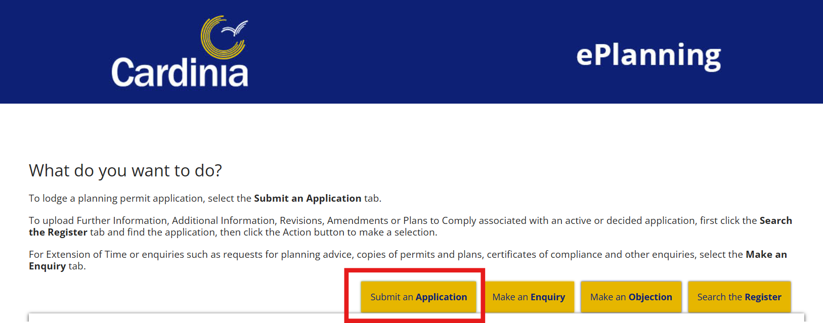

How do I lodge an application to amend a permit?
An amendment to a permit may include changes to the permit preamble (what the permit allows), changes to the conditions of the permit and changes to the endorsed plans.
Note: only the permit holder or someone with the right to use or develop the land can apply to amend a permit.
You must be logged in with your registered account to begin the application process.
- To amend a permit, select the ‘Search the Register’ tab from the ePlanning home page.

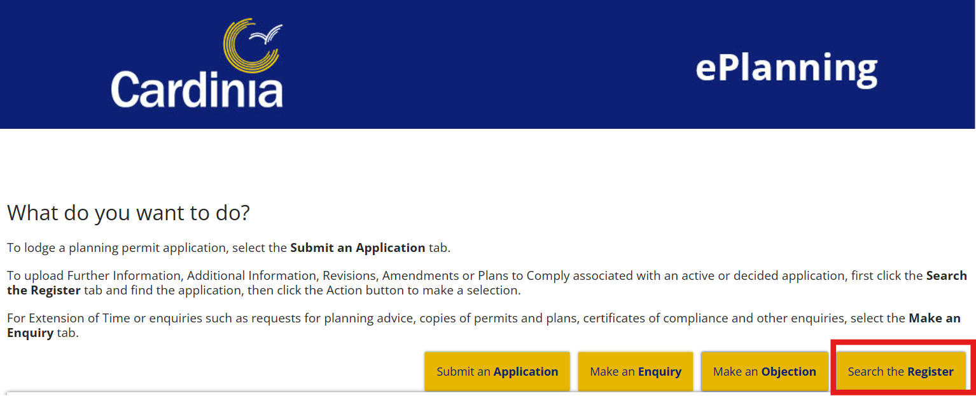

- Enter the application number and select the ‘Actions’ button to the right of the application.

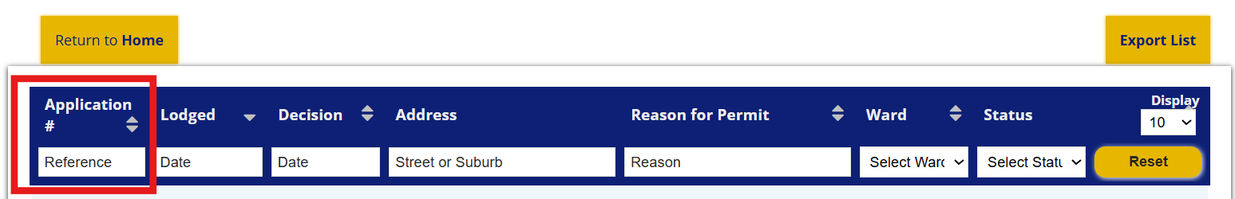

- Select ‘Amend Permit/Plans’ and follow the prompts.

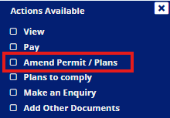

How do I submit information for an existing application?
You can use ePlanning to submit additional information for an existing permit application. This includes:
- Further information
- Additional documents
Please note plans must be submitted in standard PDF format, not PDF/A or PDF/B. The maximum file size is 1000MB.
You must be logged in with your registered account to begin the submission process.
- Go to your ‘Activities’ section towards the bottom of the ePlanning home page.
- Select ‘Actions’ to the right of the relevant activity and choose the applicable action.
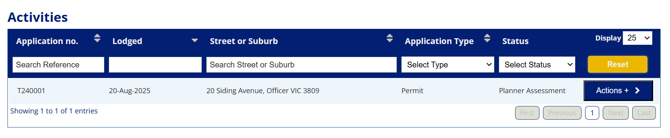
To submit Further Information:

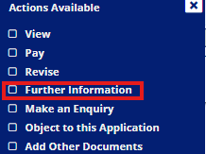

To submit Additional Documents:

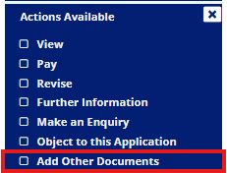

- Once you have selected the applicable action, follow the prompts on the screen and submit your documents.

How do I pay fees (or view outstanding fees) for my application?
You can pay all fees through ePlanning including:
- Application fees (for permits and amendments to permits)
- Advertising/notice fees
- Section 57A fees
You must be logged in with your registered account to pay fees.
- Select the ‘Search the Register’ button from the ePlanning home page.



- Enter the application number and select the ‘Actions’ button.

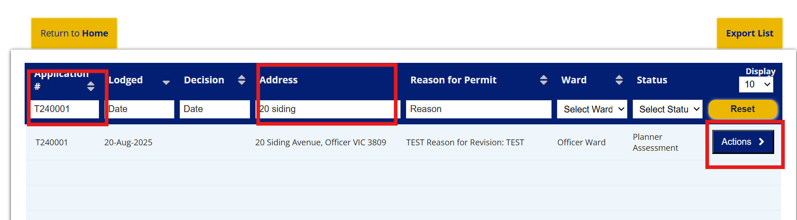

- Select ‘Pay’.

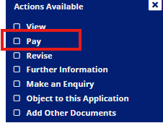

- Follow the prompts to make payment.
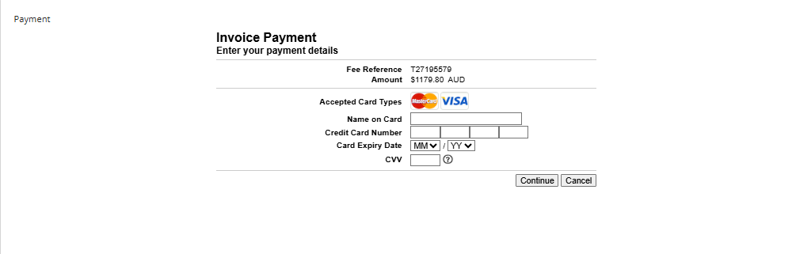

OR
- Go to the ‘Activities’ section towards the bottom of the ePlanning home page.

- Select ‘Actions’ to the right of the relevant activity and select ‘Pay’.

- Follow the prompts to make payment.

How do I submit plans to comply with a permit condition?
Planning permits typically include a range of conditions that must be met when developing or using land in a specific way. This may include a requirement for the submission of amended plans.
You must be logged in with your registered account to submit plans to comply with permit conditions.

- Select the ‘Search the Register’ button.

- Enter the application number or address and select the ‘Actions’ button.

- Select ‘Plans to Comply’ and follow the prompts.

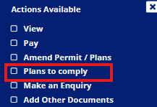

How do I make a submission (objection or support) for an application?
You must be logged in with your registered account to make a submission to an application.

- Select ‘Make an Objection’ tab from the ePlanning home page and use the filters to find the application you are interested in:


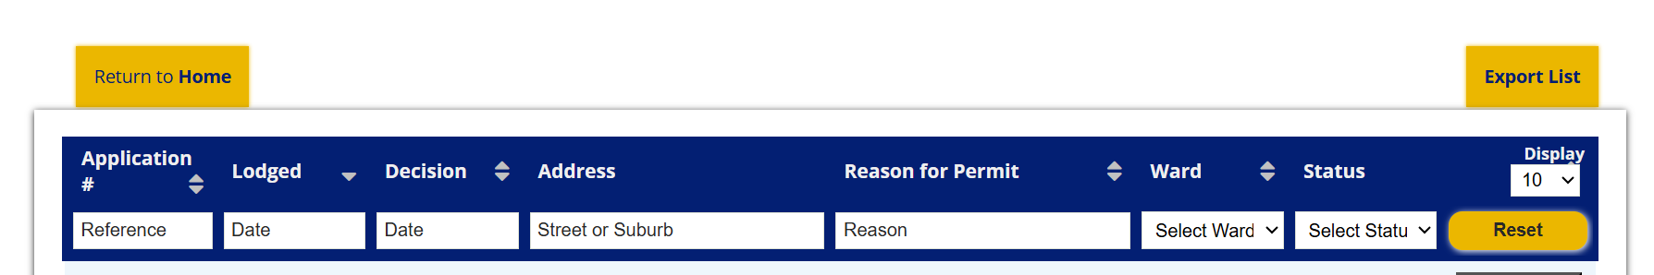

- Once you have found the relevant application, select the ‘Actions’ button and a dropdown menu will appear.
- Select ‘Make a Submission’ and follow the prompts.

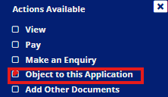

How to lodge an Enquiry?
You can submit an enquiry for a number of requests, including:
- A request for written planning advice
- A request for copies of planning permits and endorsed plans
- An application for a certificate of compliance under s97 of the Planning and Environment Act 1987
- An application to amend or end a section 173 Agreement
You must be logged in with your registered account to commence the enquiry process.

- Select ‘Make an Enquiry’ from the ePlanning home page.

- Select the relevant enquiry type and follow the prompts.
Where relevant, provide as much detail and supporting documents as possible, including:
- A detailed written description of the enquiry.
- Title documents
- Copies of plans

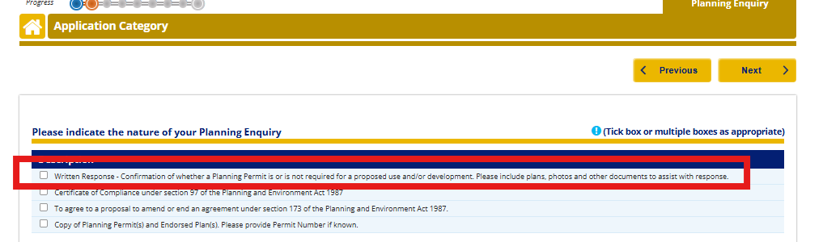

How do I access the Planning Register?
The Planning Register provides access to details of active and previous applications and permits. It also allows you to track the progress of planning permit applications.

If logged in to a registered account, follow the below steps.

- Select ‘Search the Register’ tab from the ePlanning home page.



- Use the filters at the top of the screen to refine your selection.

- Click the ‘Actions’ button, then select ‘View’

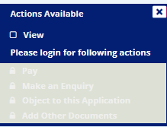

You can also access the Planning Register without a registered account by following the below step.
- Go to Cardinia Planning Portal enter the reference number or address (if known) in the ‘Planning Register’ section select ‘Search’. If details are not known, you can select ‘Search’ without any details being entered.

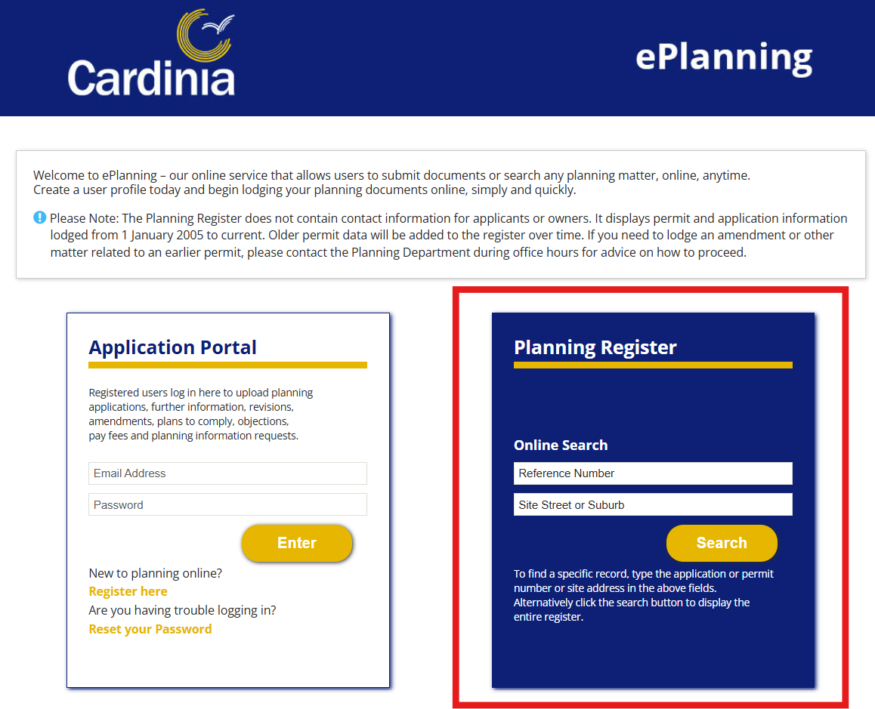

How do I amend my current application for a planning permit?
You can request to amend an application that is currently in progress. The amendment may include
- an amendment to the use or development mentioned in the application
- an amendment to the description of land to which the application applies
- an amendment to any plans and other documents forming part of or accompanying the application.
You must be logged in with your registered account to commence the amendment process.
- Go to your ‘Activities’ section towards the bottom of the ePlanning home page
- Select ‘Actions’ to the right of the relevant activity and choose the applicable option.

- Select ‘Revise’ and follow the prompts.

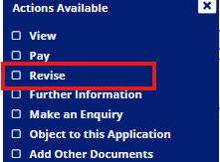

Applications that cannot be lodged via ePlanning
The following application types cannot currently be lodged via ePlanning:
- Secondary consent
- Extension of time
- Pre-application meetings
- Consent to build outside of building envelope.
These applications are lodged via separate processes on the Cardinia website. More information on submitting each application type is provided below.

How to lodge a secondary consent application
To lodge a Secondary Consent Application, visit the Cardinia Shire Council website, search for ‘secondary consent,’ and complete the electronic form provided for submission.
You should apply for secondary consent if ALL of the following conditions are met:
- You only want to make minor changes to the approved plans;
- The original permit contains the condition: 'The layout of the site and the size of the proposed buildings and works, as shown on the approved plan/s, must not be altered or modified without the consent in writing of the Responsible Authority' (or similar);
- The proposed change only involves amendments to the plans, and does not conflict with or require changes to the permit description or conditions; and
- The proposed change is minor and would not require advertising.

How to lodge an extension of time (for a planning permit that has already been issued)
To lodge an Extension of Time Application, visit the Cardinia Shire Council website, search for ‘extending a planning permit,’ and complete the electronic form provided for submission.
If the permit has expired (for example, you haven’t commenced within the timeframe or completed within the timeframe), you may not be eligible to extend the permit. Please contact us for further advice.

How do I request a pre-application meeting?
We offer a pre-application meeting service to provide feedback and help applicants prepare for a planning permit application.
Pre-Application advice will identify any concerns or suggestions for improvement on your future application. It should be viewed as preliminary advice only and does not guarantee that a permit will be issued.
To request a pre-application meeting:
Request an Intermediate pre application meeting - Request pre-application advice
- Meeting (online or in person) with allocated planner
- Written response within 14 days of meeting with allocated planner
Request an Advanced pre application Meeting - Request pre-application advice
- Meeting (online or in person) with allocated Planner and representatives from relevant internal Council Departments
- Internal referral responses included within Council’s response
- Written response within 1 month of meeting with allocated Planner.

How to apply for consent to build outside of building envelope
To submit an application for consent to build outside of a building envelope, select the following link and fill in the form and pay the relevant fee.
Application for consent to build outside of building envelope

What if I need assistance?
In Person: Visit us at our Civic Centre, 20 Siding Avenue, Officer.
Email: mail@cardinia.vic.gov.au
Phone: 1300 787 624
Web: www.cardinia.vic.gov.au
Translation Information
If you need an interpreter, call the Translating and Interpreting Service (TIS National) on 131 450 to speak to an interpreter. Ask them to phone Cardinia Shire Council on 1300 787 624
National Relay Service (NRS)
TTY: 133 677 (ask for 1300 787 624)
Speak and Listen (speech-to-speech relay): 1300 555 727 (ask for 1300 787 624)

